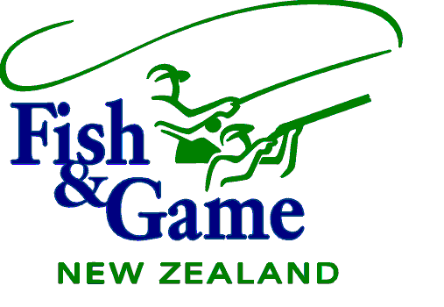

WELLINGTON FISH AND GAME COUNCIL

MEETING AGENDA

TUESDAY 8 OCTOBER 2019

To request Agenda items please phone the office 06 3590409 or email wellington@fishandgame.org.nz

AGENDA
Location: Tuesday 8th October 2019 at Club Wairarapa
20 Essex Street, Masterton at 3pm

1 | Present and In Attendance
2 | Apologies
3 | Conflict of Interest
4 | Minutes 20 August 2019 | 1-14
5 | Matters Arising  - Review Actions  - Biodiversity Strategy Consultation  - NPS / NES Consultation | 15-35
6 | National Council Business – NZ Council Meeting held on 9th – 10th August 2019 | 36-52
7 | Public Forum | 53
8 | Health and Safety | 54-56
9 | 2020 Meeting Timetable/Venues | 57-58
10 | Consideration of Hunting Season Conditions - update | 59-65
11 | Licence Management System Contract | 66-77
12 | Policy Review – Update  - Policy Review Timetable | 78-80
13 | Project reports 2018/2019 | 81
14 | Upland Game Properties with Special Conditions 2020 - update | 82
15 | Western Region Resource Consent Applications | 83-108
16 | One Plan Implementation – Update  - Plan Change 2 | 109-115
17 | Greater Wellington Regional Council – Natural Resource Plan | 116
18 | Wairarapa Water Irrigation Project - Update | 117
19 | Lake Wairarapa – Update  - Treaty Settlement Update  - Fish Research Project Update  - Fish Removal Project  - Mudfish Relocation Project - update | 118
20 | Junior/Novice – update  - Fish in Schools  - Junior Opportunities for Fishing | 119
21 | Fish and Game R3 Marketing Update | 120-123
22 | Access Issues – Update | 124-133
23 | Management Report | 134-142
24 | Fishing and Game Licence Sales | 143-156
25 | Expenditure Report / Financial Transactions | 157-172
26 | Correspondence / Media | 173-178
27 | Recognition & Contribution Awards | 179-181
28 | Wellington Conservation Board | 182-183
29 | General Business | 184

WELLINGTON FISH AND GAME COUNCIL

The Chairman
Wellington Fish and Game Council

AGENDA MANAGEMENT

Council should do the following things;

- Review the Annual Program for Meeting Agenda’s and decide what items should be added to it.
- Review the Current Agenda, and decide on the order of items, the timing requirements for items, any items to be deferred, or any new business to be tabled.
- Review Next Two Meeting Agendas, to see what’s coming, and decide on anything that needs to be included or changed.

No resolutions should be necessary here, unless to resolve debate on a future course of action. The Minutes will record all issues that Council agrees, and these will be reflected in future Action Lists, Annual Programs, and Agendas as may be appropriate.

Meeting Dates & Venues Wellington Fish & Game Council 2019

DATE | VENUE
Tuesday, 12 February 2019 | Coachman Hotel, Palmerston North
Tuesday, 26 March 2019 | Cossie Club, Upper Hutt
Tuesday, 11 June 2019 | Club Wairarapa (RSA), Masterton
Tuesday, 20 August 2019 | Cossie Club, Upper Hutt
Tuesday, 8 October 2019 | Club Wairarapa (RSA), Masterton
Tuesday, 3 (AGM) December 2018 | Coachman Hotel, Palmerston North

WELLINGTON FISH & GAME COUNCIL

ANNUAL PROGRAM for MEETING AGENDAS. 2019

Meeting | Board | Operational | Statutory | Strategic and Policy
Tuesday 12th February 2019 | All Board Items. | All Operational Items, to be Received. | Game Season regulations recommendations confirmed | Strategy discussion
Tuesday 26th March 2019 | All Board Items. | All Operational Items, to be Received | Draft Annual Plan and budget
Tuesday 11th June 2019 | All Board Items. | All Operational Items, to be Received | Draft Anglers Notice recommendations
Tuesday 20th  August 2019 | All Board Items. | All Operational Items, to be Received | Adopt Annual Plan
Tuesday 8th October 2019 | All Board Items. | All Operational Items, to be Received
Tuesday 3rd December 2019/AGM | All Board Items. | All Operational Items, to be Received  Annual Reports, to be Received | Annual General Meeting. Annual Report to Adopt and Present. Game season regulations
Board Items are as follows.
- Present and in Attendance.
- Apologies.
- Minutes of Previous Meeting to be Approved.
- Matters Arising from the Minutes.
- Agenda Management, including review of Action List, review of Annual Program for Meeting Agendas, and review of current and next two meeting agendas.
- Chairman’s Business.
- New Zealand Fish & Game Council Business.

Operational Items are as follows.

- Management Report, to be Received.
- Schedules of Financial Transactions, Bank Balances, and Correspondence, to be Received.
- Project Expenditure Report, to be Received.
- Licence Sales Reports, to be Received.

Process to Get Items on Agenda is as follows.
- Raise the matter in General Business at the end of the meeting, to get it resolved there and then, or
- Raise the matter under Agenda Management near the beginning of the meeting, to seek Council’s agreement for a Councillor and/or management to prepare and present a paper on the subject for formal inclusion in a subsequent meeting agenda, or
- Present a paper as a Notice of Motion, following the procedure of 2.16 on page 24 of the Fish and Game Rules in Part 4 Policy Manual.

