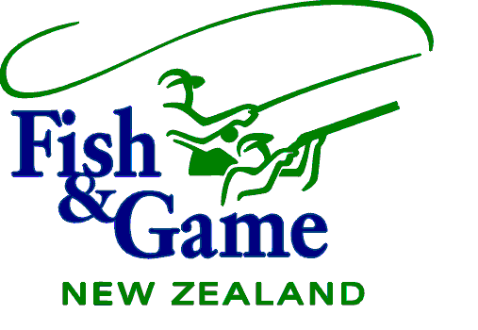

WELLINGTON FISH AND GAME COUNCIL

MEETING AGENDA

TUESDAY 13 OCTOBER 2020

To request Agenda items please phone the office 06 3590409 or email wellington@fishandgame.org.nz

AGENDA

Location: Tuesday 13 October 2020 at 3pm at Club Wairarapa,
20 Essex Street, Masterton

1 | Present and In Attendance
2 | Apologies
3 | Conflict of Interest  - Register  - COI Management Plan
4 | Minutes 11 August 2020 | 1-14
5 | Matters Arising | 15-20
6 | National Council Business  - NZ Council Meeting held on 21 -23 August 2020 | 21-40
7 | Public Forum | 41
8 | Health and Safety | 42-44
9 | 2021 Meeting Timetable | 45-49
10 | Fish and Game Review | 50
11 | Non-Resident Levy Changes | 51-57
12 | Policy Review – Update  - Reserves Policy  - Customs Import Prohibition (Trout) order | 58-61
13 | Communication Strategy Update | 62
14 | Draft Sports Fish & Game Bird Management Plan | 63
15 | Project Reports | 64
16 | Licence Management Contract (update) | 65-66
17 | R3 Marketing Update | 67
18 | Action Plan for Healthy Rivers – Update  - Farm Plans  - Media | 68-75
19 | One Plan Implementation – Plan Change 2 (update) | 76
20 | Wairarapa Water Project - Update | 77-79
21 | Western Region Resource Consent Applications - Update | 80
22 | Lake Wairarapa – Update  - Treaty Settlement Update  - Fish Research Project Update  - Fish Removal Project  - Stand Allocation and review  - Funding from Central Government | 81-88
23 | Research – Update  - eDNA Project  - Native Fish – Trout Interaction | 89-91
24 | Junior/Novice – update | 92
25 | Access Issues – Update  Otaki River (hunting)  Waiterere Forest (hunting)  Santoft Forest (hunting)  Pencarrow Lakes (hunting) | 93
26 | Management Report | 94-101
27 | Fishing and Game Licence Sales | 102-115
28 | Expenditure Report / Financial Transactions | 116-128
29 | Correspondence /Media | 129-141
30 | Recognition & Contribution Awards (update) | 142-146
31 | Wellington Conservation Board | 147-148
32 | General Business | 149

WELLINGTON FISH AND GAME COUNCIL

The Chairman
Wellington Fish and Game Council

AGENDA MANAGEMENT

Council should do the following:

- Review the Annual Program for Meeting Agenda’s and decide what items should be added to it.
- Review the Current Agenda, and decide on the order of items, the timing requirements for items, any items to be deferred, or any new business to be tabled.
- Review Next Two Meeting Agendas, to see what’s coming up, and decide on anything that needs to be included or changed.

No resolutions should be necessary here, unless to resolve debate on a future course of action. The Minutes will record all issues that Council agrees, and these will be reflected in future Action Lists, Annual Programs, and Agendas as may be appropriate.

Meeting Dates & Venues Wellington Fish & Game Council 2020

DATE | VENUE
Tuesday, 11 February 2020 | Coachman Hotel, Palmerston North
Tuesday, 24 March 2020 | Club Wairarapa (RSA), Masterton via Teams
Tuesday, 9 June 2020 | Via Zoom
Tuesday, 11 August 2020 | Coachman Hotel, Palmerston North
Tuesday, 13 October 2020 | Club Wairarapa (RSA), Masterton
Tuesday, 8 (AGM) December 2020 | Cossie Club, Upper Hutt

WELLINGTON FISH & GAME COUNCIL

ANNUAL PROGRAM for MEETING AGENDAS 2020

Meeting | Board | Operational | Statutory | Strategic and Policy
Tuesday 11th February 2020 | All Board Items. | All Operational Items, to be Received. | Game Season regulations recommendations confirmed | Strategy discussion
Tuesday 24th March 2020 | All Board Items. | All Operational Items, to be Received | Draft Annual Plan and budget
Tuesday 9th June 2020 | All Board Items. | All Operational Items, to be Received | Draft Anglers Notice recommendations
Tuesday 11th  August 2020 | All Board Items. | All Operational Items, to be Received | Adopt Annual Plan
Tuesday 13th October 2020 | All Board Items. | All Operational Items, to be Received
Tuesday 8th December 2020/AGM | All Board Items. | All Operational Items, to be Received  Annual Reports, to be Received | Annual General Meeting. Annual Report to Adopt and Present. Game season regulations

Board Items are as follows.
- Present and in Attendance.
- Apologies.
- Minutes of Previous Meeting to be Approved.
- Matters Arising from the Minutes.
- Agenda Management, including review of Action List, review of Annual Program for Meeting Agendas, and review of current and next two meeting agendas.
- Chairman’s Business.
- New Zealand Fish & Game Council Business.

Operational Items are as follows.

- Management Report, to be Received.
- Schedules of Financial Transactions, Bank Balances, and Correspondence, to be Received.
- Project Expenditure Report, to be Received.
- Licence Sales Reports, to be Received.

Process to Get Items on Agenda is as follows.
- Raise the matter in General Business at the end of the meeting, to get it resolved there and then, or
- Raise the matter under Agenda Management near the beginning of the meeting, to seek Council’s agreement for a Councillor and/or management to prepare and present a paper on the subject for formal inclusion in a subsequent meeting agenda, or
- Present a paper as a Notice of Motion, following the procedure of 2.16 on page 24 of the Fish and Game Rules in Part 4 Policy Manual.

