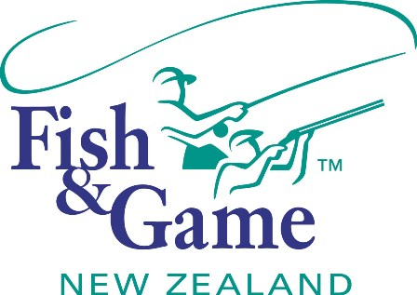
FISH & GAME N.Z -WEST COAST REGION
COUNCIL MEETING & A.G.M
TO BE HELD ON TUESDAY 10th DECEMBER AT REVINGTONS HOTEL COMMENCING 7:00PM
FOLLOWED BY THE A.G.M at 8:00PM (Approx)

AGENDA

- Welcome.
- Apologies.
- Conflicts of interest register.
- Minutes of October meeting.
- Matters arising.
- Correspondence (inwards schedule enclosed).
- 2012 Council Elections review and recommendations - NZC
- Financial Report (enclosed).
- Managers Report (enclosed).
- N.Z. Council Report – Jean Willis.
- General Business.
- Enhancement strategy – Mark Smith
- Wilderness Quest Ltd application for gamebird MOU – Manager
- 2013 Game Season Notice – resolution required for recommendation to Minister – Manager and Chair
- Adoption of Annual Report - Chair
- Managers Performance Appraisal – Publicly excluded session
- Supper.
2013 Annual Public Meeting (8:00pm approx)
- Presentation of the 2012/13 Annual Report
- General Business

