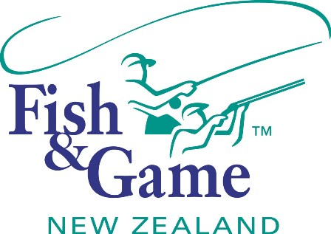
FISH & GAME N.Z -WEST COAST REGION
COUNCIL MEETING

TO BE HELD ON TUESDAY 8th OCTOBER AT HOKITIKA OFFICE COMMENCING 7:00PM

AGENDA

- Welcome.
- Apologies.
- Conflicts of interest register.
- Minutes of August meeting.
- Matters arising.
- Correspondence (inwards schedule enclosed).
- Letter of thanks re: Junior Pheasant Hunt
- Financial Report (enclosed).
- Managers Report (enclosed).
- N.Z. Council Report – Jean Willis.
- Supper.
- General Business.
- Councilor Service Recognition (J Derks)
- Sportsfish Enhancement Strategy (M Smith)
- Presentations
- West Coast Salmon Life History Research (Dean)
- National Licence Sales 2012/13 season

