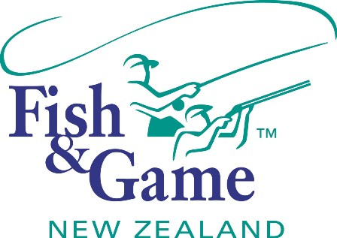
FISH & GAME N.Z -WEST COAST REGION
COUNCIL MEETING

TO BE HELD ON TUESDAY 12th AUGUST AT THE KINGSGATE HOTEL AT 7:00PM

AGENDA

- Welcome.
- Apologies.
- Conflicts of interest register.
- Minutes of June meeting.
- Matters arising.
- Correspondence (inwards schedule enclosed).
- Letter from Neil Hayes.
- Letter from South Westland Area School.
- Financial Report (enclosed).
- Managers Report (enclosed).
- N.Z. Council Report – Jean Willis.
- General Business.
- Heaphy Road Stopping – (8pm) Presentation from Gloriavale Christian Community
- Spawning Surveys
- Supper

