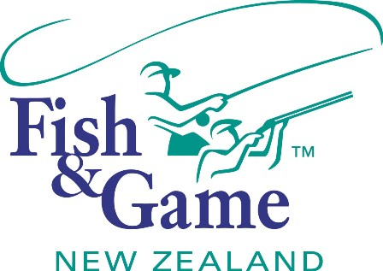
FISH & GAME N.Z -WEST COAST REGION
COUNCIL MEETING & A.G.M
TO BE HELD ON TUESDAY 9th DECEMBER AT THE DENNISTON DOG HOTEL COMMENCING 7:00PM
FOLLOWED BY THE A.P.M at 8:00PM (Approx)

AGENDA

- Welcome.
- Apologies.
- Conflicts of interest register.
- Minutes of October meeting.
- Matters arising.
- Correspondence (inwards schedule enclosed).
- NZ Council – National Policies response.
- CSI Council – Felt soled waders.
- Financial Report (enclosed).
- Managers Report (enclosed).
- Governance Forum Report – Andy Harris.
- General Business.
- 2014 Game Season Notice – Review with resolution required for recommendation to Minister.
- Adoption of Annual Report - Chair
- Managers Performance Appraisal – Publicly excluded session
2013 Annual Public Meeting (8:00pm approx)
- Presentation of the 2013/14 Annual Report
- General Business
- Supper

