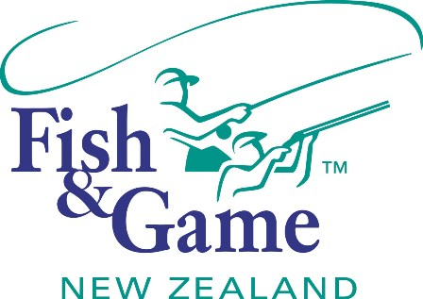
FISH & GAME N.Z -WEST COAST REGION
COUNCIL MEETING
TO BE HELD ON TUESDAY 11th FEBRUARY AT HOKITIKA OFFICE 7:00PM

AGENDA

- Welcome.
- Apologies.
- Conflicts of interest register.
- Minutes of December meeting.
- Matters arising.
- Correspondence (inwards schedule enclosed).
- Prosecution Policy Paper – NZC
- Sub-gauge transition paper – NZC
- Licence Categories Paper - NZC
- Financial Report (enclosed).
- Managers Report (enclosed).
- N.Z. Council Report – Jean Willis.
- General Business.
- Inangahua Hydro
- Managers Performance Appraisal – Publicly excluded session
- Supper.

