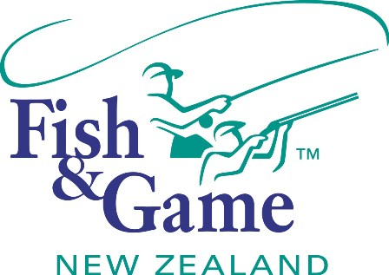
FISH & GAME N.Z -WEST COAST REGION
COUNCIL MEETING

TO BE HELD ON TUESDAY 10th JUNE AT FISH AND GAMES HOKITIKA OFFICE AT 7:00PM

AGENDA

- Welcome.
- Apologies.
- Conflicts of interest register.
- Minutes of April meeting.
- Matters arising.
- Correspondence (inwards schedule enclosed).
- Letter from Northland Fish and Game to NZC.
- NZC – Licence Fee Recommendation.
- Financial Report (enclosed).
- Managers Report (enclosed).
- N.Z. Council Report – Jean Willis.
- General Business.
- Anglers Notice (Recommendation to Minister).
- Budget, Operational Workplan and policies (Draft for approval).
- 2014/15 Licence fee recommendation.
- Councillor recognition medals.
- Supper

