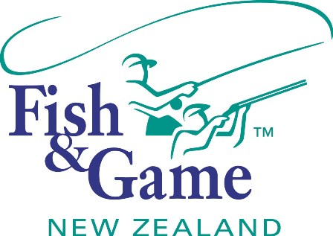
FISH & GAME N.Z -WEST COAST REGION
COUNCIL MEETING

TO BE HELD ON TUESDAY 14th OCTOBER AT HOKITIKA OFFICE COMMENCING 7:00PM

AGENDA

- Welcome.
- Apologies.
- Conflicts of interest register.
- Minutes of August meeting.
- Matters arising.
- Correspondence (inwards schedule enclosed).
- Letter from NZC - Co-ordination and audit function legal opinion
- Letter from NZC – Fishing Guides Licence
- Financial Report (enclosed).
- Managers Report (enclosed).
- N.Z. Council Report – Jean Willis.
- General Business.
- Honorary Ranger Program
- Supper.

