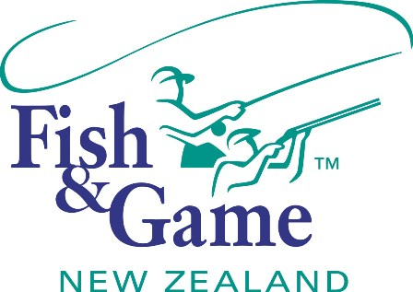
FISH & GAME N.Z -WEST COAST REGION
COUNCIL MEETING

TO BE HELD ON WEDNESDAY 15th APRIL 2015 AT REVINGTONS HOTEL GREYMOUTH AT 7:00PM

AGENDA

- Welcome.
- Apologies.
- Conflicts of interest register.
- Minutes of February meeting.
- Matters arising.
- Correspondence (inwards schedule enclosed).
- Financial Report (enclosed).
- Managers Report (including);
- Drift Dive Report.
- Lake Kaniere Netting Report.
- Paradise Shelduck Moult Survey Report.
- N.Z. Council Report – Jean Willis.
- General Business.
- 2015/16 Draft Budget.

