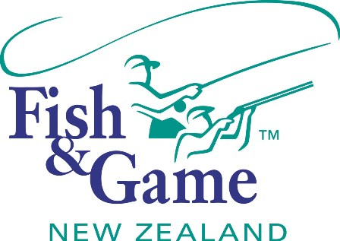
FISH & GAME N.Z -WEST COAST REGION
COUNCIL MEETING

TO BE HELD ON WEDNESDAY 19th AUGUST AT THE ASHLEY HOTEL AT 7:00PM

AGENDA

- Welcome.
- Apologies.
- Conflicts of interest register.
- Minutes of June meeting.
- Matters arising.
- Correspondence (inwards schedule enclosed).
NZC Letter re Non-residents licence income.
- Financial Report (enclosed).
- Managers Report (enclosed).
- N.Z. Council Report – Jean Willis.
- General Business.
- Response to NZC Non-residents licence correspondence
- OSPRI – Imogen Squires
- Supper

