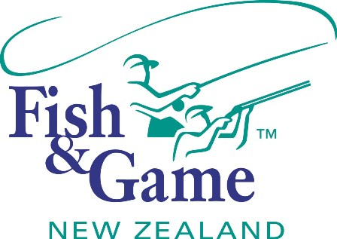
FISH & GAME N.Z -WEST COAST REGION
COUNCIL MEETING
TO BE HELD ON TUESDAY 10th FEBRUARY AT HOKITIKA OFFICE 7:00PM

AGENDA

- Welcome.
- Apologies.
- Conflicts of interest register.
- Minutes of December meeting.
- Matters arising.
- Correspondence (inwards schedule enclosed).
- Heaphy Road Opinion – Abercrombie & Associates
- Felt Soled Waders – Otago Fish and Game Council
- Financial Report (enclosed).
- Managers Report (enclosed).
- N.Z. Council Report – Jean Willis.
- General Business.
- Council Meeting Dates
- 2015/16 Workplan – Council Input.
- Operational Policies/Strategies review.
- Managers Performance appraisal.
- Supper.

