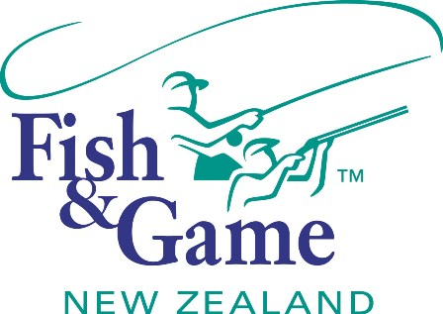
FISH & GAME N.Z -WEST COAST REGION
COUNCIL MEETING

TO BE HELD ON WEDNESDAY 17th JUNE AT FISH AND GAMES HOKITIKA OFFICE AT 7:00PM

AGENDA

- Welcome.
- Apologies.
- Conflicts of interest register.
- Minutes of April meeting.
- Matters arising.
- Correspondence (inwards schedule enclosed).
- NZC – Licence Fee Recommendation.
- NZC – National Reparation Policy.
- NZC – Changes in ethnicity.
- NZC –Non-resident fish licence revenue.
- OSPRI – Placement of 1080 on riverbeds.
- Financial Report (enclosed).
- Managers Report (enclosed).
- N.Z. Council Report – Jean Willis.
- General Business.
- Anglers Notice (Recommendation to Minister).
- Operational Workplan & Enhancement Strategy (Draft for approval).
- Councilor recognition ceremony.
- Fish and Game West Coast Strategic Direction. (D Heine)
- Supper

