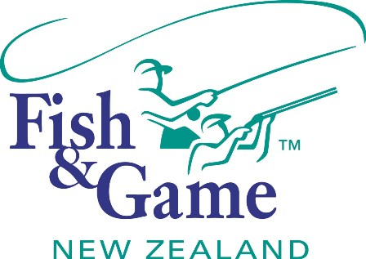
FISH & GAME N.Z -WEST COAST REGION
COUNCIL MEETING

TO BE HELD ON WEDNESDAY 21st OCTOBER AT HOKITIKA OFFICE COMMENCING 7:00PM

AGENDA

- Welcome and legislation overview.
- Apologies.
- Appointment of Chair.
- Appointment of NZ Council delegate.
- Meeting Schedule.
- Conflicts of interest register.
- Minutes of August meeting.
- Matters arising.
- Correspondence (inwards schedule enclosed).
- Managers Report (enclosed).
- General Business.
- Backcountry fisheries.
- Supper.

