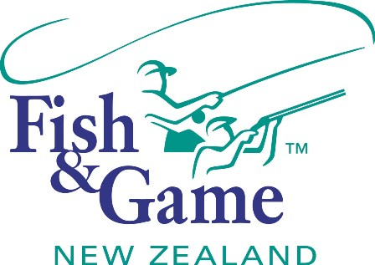
FISH & GAME N.Z -WEST COAST REGION
COUNCIL MEETING

TO BE HELD ON WEDNESDAY 20th APRIL 2016 at the
FISH AND GAME OFFICE - HOKITIKA AT 7:00PM

AGENDA

- Welcome.
- Apologies.
- Conflicts of interest register.
- Declaration of interest register.
- Minutes of December meeting.
- Matters arising.
- Correspondence (inwards schedule enclosed).
- Financial Report (enclosed).
- Manager’s Report (including);
- Drift Dive Report.
- Paradise Shelduck Moult Survey Report.
- N.Z. Council Report – Andy Harris.
- General Business.
- 2016/17 Draft Operational Work Plan (OWP).
- 2016/17 Fisheries Regulation review.

