
Taranaki Region

2018 SUMMER SEASON FOR
PARADISE SHELDUCK
TARANAKI AREA C ONLY

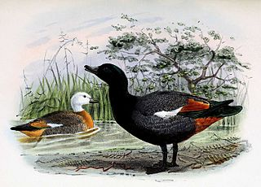
24TH & 25TH FEBRUARY 2018
AND
3TH & 4TH MARCH 2018

BAG LIMIT 10 BIRDS PER DAY
Hunting hours - 6:30am to 8:00pm

A permit at a cost of $5.00 and a 2017 gamebird hunting licence is required. If a 2017 game licence was not purchased last year, 2017 day licences may be purchased on line at www.fishandgame.org.nz for $21.00 per day

